Often user biases toward the proposed system, political climate within the organization, interpersonal problems etc. will make systems analysis and the design of the system difficult.  Describe the circumstances and how your group is planning to overcome these (user biases) problems.  For example, you may be asking employees to help build their own guillotine. (#8)

**Describe the circumstances and how your group is planning to overcome these (user biases) problems.**

**COLLECTING INFORMATION TECHNEQUES**

INTERVIEWING

(Chapter 6 Page 154)

**Describe the circumstances and how your group is planning to overcome these (user biases) problems.**

**interviewing groups**

One drawback to using interviews to collect systems requirements is the need for the analyst to reconcile apparent contradictions in the information collected. A series of interviews may turn up inconsistent information about the current system or its replacement. You must work through all of these inconsistencies to figure out what might be the most accurate representation of current and future systems. Such a process requires several follow-up phone calls and additional interviews. Catching important people in their offices is often difficult and frustrating, and scheduling new interviews may become very time consuming. In addition, new interviews may reveal new questions that in turn require additional interviews with those interviewed earlier. Clearly, gathering information about an information system through a series of individual interviews and follow-up calls is not an efficient process.

Another option available is to conduct a group interview. In a group interview, several key people are interviewed at once. To make sure all of the important information is collected, you may conduct the interview with one or more analysts. In the case of multiple interviewers, one analyst may ask questions while another takes notes, or different analysts might concentrate on different kinds of information. For example, one analyst may listen for data requirements while the other notes the timing and triggering of key events. The number of interviewees involved in the process may range from two to however many you believe can be comfortably accommodated.

(When interviewing the Weingarten staff, to find out system process requirments, we did split up which information each of us is seeking during the interview. We even set up questions to prob for information we are seeking)

A group interview has a few advantages. One, it is a much more effective use of time than a series of interviews with individuals, although the time commitment of the interviewees may be more of a concern. Two, interviewing several people together allows the interviewers to hear the opinions of other key people and gives them the opportunity to agree or disagree with their peers. Synergies also often occur. (as the Venture Café says, creating serendipitous collisions) For example, the comments of one person might cause another person to say, “That reminds me of” or “I didn’t know that was a problem.” The interviewer can benefit from such a discussion as it helps identify issues on which there is general agreement and areas where views diverge, or start to contradict each other, widely. The primary disadvantage of a group interview is the difficulty in scheduling it. The more people who are involved, the more difficult it will be finding a convenient time and place for everyone. Modern videoconferencing technology can minimize the geographical dispersion factors that make scheduling meetings so difficult. Group interviews are at the core of the Joint Application Development (JAD) process. JAD (Joint Application Development) is a methodology that involves the client or [end user](http://whatis.techtarget.com/definition/end-user) in the design and development of an [application](http://searchsoftwarequality.techtarget.com/definition/application), through a succession of collaborative workshops called JAD sessions. Chuck Morris and Tony Crawford, both of IBM, developed JAD in the late 1970s and began teaching the approach through workshops in 1980The JAD approach, in comparison with the more traditional practice, is thought to lead to faster development times and greater client satisfaction, because the client is involved throughout the development process. In comparison, in the traditional approach to systems development, the developer investigates the system requirements and develops an application, with client input consisting of a series of interviews. A variation on JAD, [rapid application development (RAD)](http://searchsoftwarequality.techtarget.com/definition/rapid-application-development) creates an application more quickly through such strategies as using fewer formal methodologies and reusing software components.

**Nominal Group Technique**

Nominal Group Technique (NGT)

A facilitated process that supports idea generation by groups. At the beginning of the process, group members work alone to generate ideas. The ideas are then pooled under the guidance of a trained facilitator. Many different techniques have been developed over the years to improve the process of working with groups. One of the more popular techniques for generating ideas among group members is called **Nominal Group Technique (NGT). NGT** is exactly what the name indicates, the individuals working together to solve a problem are a group in name only, or nominally. Group members may be gathered in the same room for **NGT**, but they all work alone for a period of time. Typically, group members make a written list of their ideas. At the end of the idea-generation time, group members pool their individual ideas under the guidance of a trained facilitator. Pooling usually involves having the facilitator ask each person in turn for an idea that has not been presented before. As the person reads the idea aloud, someone else writes down the idea on a blackboard or flip chart. After all of the ideas have been introduced, the facilitator will then ask for the group to openly discuss each idea, for clarification.

Once all of the ideas are understood by all of the participants, the facilitator will try to reduce the number of ideas the group will carry forward for additional consideration. There are many ways to reduce the number of ideas. The facilitator may ask participants to choose only a subset of ideas that they believe are important. Then the facilitator will go around the room, asking each person to read aloud an idea that is important to him or her that has not yet been identified by someone else.

Or the facilitator may work with the group to identify and either eliminate or combine ideas that are very similar to each other’s ideas. At some point, the facilitator and the group will end up with a set of ideas, which can be further prioritized.

In a requirements determination context, the ideas being sought in an **NGT** exercise would typically apply to problems with the existing system or ideas for new features in the system being developed (just as we are doing for The Weingarten). The end result would be a list of either problems or features that the group of members themselves had generated and prioritized. There should be a high level of ownership of such a list, at least for the group that took part in the NGT exercise.

There is some evidence to support the use of the NGT exercise to help focus and refine the work the group put in that the number and quality of ideas that result from an NGT exercise may be higher than what would normally be obtained from an unfacilitated group meeting. (which we had issues with throughout the semester. The Project Manager style of managing didn’t mesh well with more than 2/3’s of the group members style of working on coming up with the new and improved proposed system processes). An NGT exercise could be used to complement the work done in a typical group interview or as part of a Joint Application Design effort.

**Determining system requirements:**

**Directly observing users**

(Chapter 6 Page 155-56)

**Describe the circumstances and how your group is planning to overcome these (user biases) problems.**

All the methods of collecting information that have been discussed up until now involve getting people to recall and convey information they have about an organizational area and the information systems that support these processes. People, how-ever, are not always very reliable informants, even when they try to be reliable and tell what they think is the truth. As odd as it may sound, people often do not have a completely accurate appreciation of what they do or how they do it. This is especially true concerning infrequent events, issues from the past, or issues for which people have considerable passion. Because people cannot always be trusted to reliably interpret and report their own actions, you can supplement and corroborate what people tell you by watching what they do or by obtaining relatively objective measures of

how people behave in work situations. (See the box “Lost Soft Drink Sales” for an example of the importance of systems analysts learning firsthand about the business for which they are designing systems.)

For example, one possible view of how a manager does their job is that a manager carefully plans activities, works for long periods of time and consistently on solving problems, and controls the pace of work. A manager might tell you that is how they spend their day. When Mintzberg (1973) observed how managers work, he found that a manager’s day is actually punctuated by many, many interruptions (which stands true with the Weingarten’s manager answering 30+ calls a day). Managers work in a fragmented manner, focusing on a problem or on a communication for only a short time before they are interrupted by phone calls or visits from their subordinates and other managers (which also stands true for our Weingarten’s manager). An information system designed to fit the work environment of our hypothetical manager would not effectively support the actual work environment in which that manager finds themselves.

**Describe the circumstances and how your group is planning to overcome these (user biases) problems.**

**DOCUMENT ANALYSIS**

**EMAIL LOGS**

As another example, consider the difference between what another employee might tell you about how much they use e-mail and how much e-mail use might be discovered through more objective means. An employee might say they are swamped with e-mail messages and that they spend a significant portion of time responding to e-mail. However, if you were able to check electronic mail records, you might find that this employee receives only 3 e-mail messages per day on average, and that the most messages they have ever received for one eight-hour period is 10. In this case, an accurate behavioral measure log was obtained showing how much e-mail this employee really copes with without having to watch him read his e-mail. (Which is what we did by recording all meetings and analyzing all current processes and systems)

**SYSTEM LOGS**

The intent behind obtaining system records and direct observation is the same, however, obtaining more firsthand and objective measures of employee interaction with information systems. In some cases, behavioral measures will be a more accurate reflection of reality than what employees believe. In other cases, the behavioral information will substantiate with what employees have already shared directly with the manager/analyst. Although observation and obtaining objective measures are desirable ways to collect important information, such methods are not always possible in real organizational settings. Thus, these methods are not totally un**biase**d (which means they are biased), just as no other one data-gathering method is un**biase**d. (??????)

**OBSERVATION SHORT-FALLS ANALYSIS**

For example, observation can cause people to change their normal operating behavior. Employees, who know they are being observed, may be nervous and make more mistakes than normal, may be careful to follow exact procedures they do not typically follow, and may work faster or slower than normal. Moreover, because observation typically cannot be continuous, you receive only a snapshot image of the person or task you observe, which may not include important events or activities. Because observation is very time consuming, you will not only observe for a limited time, but also a limited number of people and a limited number of sites. Again, observation yields only a small segment of data from a possibly vast variety of data sources. Exactly which people or sites to observe is a difficult selection problem. You want to pick both typical and atypical people and sites, and observe during normal and abnormal conditions and times to receive the richest possible data from observation.

(BOOK PAGE 155 PAGE 156)

**Describe the circumstances and how your group is planning to overcome these (user biases) problems.**

DETERMINING SYSTEM REQUIRMENTS (PAGE161)

Table 6-4: Comparison of Observation and Document Analysis

* + - TAKE AWAY:

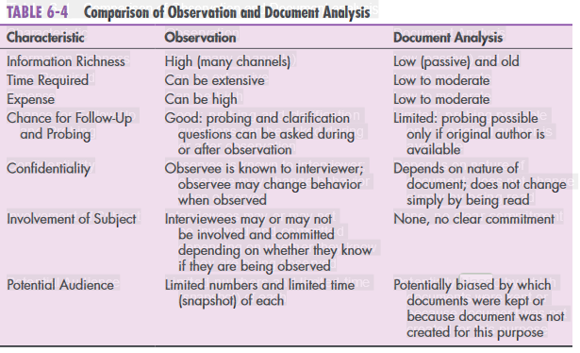

* + - * Potential Audience - > Document Analysis: Potentially **biased** by which documents were kept or because document was not created for this purpose

**overcoming user bias**

**HOW TO MINIMIZE YOUR BIASES WHEN MAKING DECISIONS**

**Describe the circumstances and how your group is planning to overcome these (user biases) problems.**

Every day, senior managers are tasked with making very significant strategic decisions for their companies, which usually require support by teams of internal and external experts and a heavy dose of research. Theoretically, knowledge-based decision making is practiced at every successful organization. First-hand experience and best sellers like Daniel Kahneman’s [Thinking, Fast and Slow](http://www.amazon.com/Thinking-Fast-Slow-Daniel-Kahneman/dp/0374275637) have confirmed an even broader range of behavioral vulnerabilities and quirks in our abilities to make decisions as human beings.

For those of us tasked with modeling the risk/reward potential of various business opportunities, the need to address these influential, often subconscious factors in the modeling process is compelling. In the enterprise risk management (ERM) arena, in particular, it is mandatory that incisive analysis of decision options means taking rigorous steps to challenge not only the scenarios we develop, but also their underlying assumptions.

Behavioral economists state, we, as people who measure risk on a regular basis, in the enterprise risk management space, outline some of the most common biases that tend to creep into all kinds of risk/reward decision making, with personal as well as professional decisions. Once sources are acknowledged as distorting the decision-making process; it allows for the strengthening of the relevance and reliability of decision-making strategies and assessment(s) of potential risk from these decisions. Embed throughout the process, biases are held by all audience(s), development team(s), competitor(s), and even the in-house team have their own human biases.

[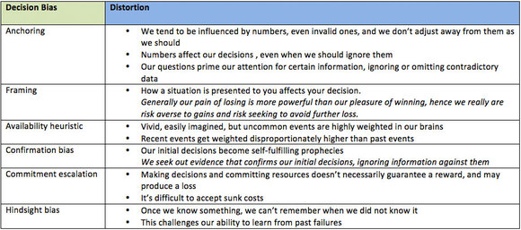](https://hbr.org/cs/assets_c/2012/09/decisionbias-2337.html)

Minimizing the impact of these biases is crucial. They can sneak into any risk/reward management scenario developed, unless considerable rigor is exercised at every stage of the process from assumption right through to the presentation of alternative scenarios, as well as other considerations. We must challenge our decision-making process by realizing that we influence and are influenced by the information at hand. The above practical approaches are not guaranteed to be optimal solutions; they have served human beings well when we were employed to do work, such as tilling the land. However, these above solutions do open us up for biased risk/reward decision-making, when applied to today’s knowledge-based work.

**To minimize bias impact, we must:**

* Search relentlessly for potentially relevant or new disconfirming evidence
* Accept the “Chief Contrarian” as part of the team
* Seek diverse outside opinion to counter our overconfidence
* Reward the process and refrain from penalizing errors when the intentions and efforts are sound
* Reframe or flip the problem on its head to see if we are viewing the situation in either a positive or negative framework
* Redefine the problem from here on out and ignore the old problem to avoid escalation of unnecessary commitment
* Develop systemic review processes that leave you a committed “out” possibility when trying to “cut the losses”
* Avoid the potential for escalation or further emotional investment in faulty decisions caused by premature “public” commitment.

Throughout the process, it’s crucial to recognize that most risk does not manifest itself from some external contingent event, but rather is driven by the behaviors and decisions of people. Only by rigorously challenging our current views of the future and long-lived underlying assumptions, this way we gain the means to manage real risks that face our enterprises. This is the “individual” element here. I am strong supporter that it doesn’t end here.

**Describe the circumstances and how your group is planning to overcome these (user biases) problems.**

**HOW TO OVERCOME BIASES:**

**Decision Making Biases**

**BIASES**

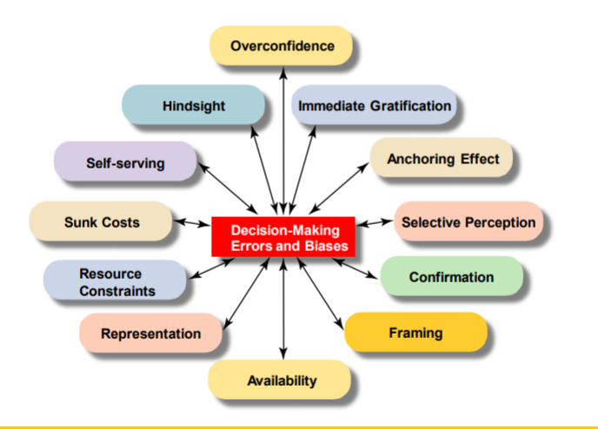[](https://hbr.org/cs/assets_c/2012/09/decisionbias-2337.html)

* + Reducing Biases
    - Objective: This module is designed to help reduce and even eliminate on-going biases that hamper successful decision-making.
    - Approach: The approach examines an array of biases to help recognize them, while outlining various techniques to help reduce and hopefully even eliminate them.
  + Decision-Making Errors and Biases
    - Anchoring Effect Bias
      * Fixate on initial information and fail to adjust for subsequent information.
      * This also happens when we are blinded by first impressions or influenced by first impressions, ideas, prices, or estimates relative to info received later.
    - Availability Heuristic Bias
      * Vivid, easily imagined, but uncommon events are highly weighted in our brains
      * Recent events get weighted disproportionately higher than past events
      * We tend to be influenced by numbers, even invalid ones, and we don’t adjust away from them as we should
      * Numbers affect our decisions, even when we should ignore them
      * Our questions prime our attention for certain information, ignoring or omitting contradictory data
      * Rely upon knowledge that is readily available rather than examine other alternatives or procedures.
      * The most recent and memorable information is given preference.
    - Commitment Escalation
      * Making decisions and committing resources doesn’t necessarily guarantee a reward, and may produce a loss
      * It’s difficult to accept sunk costs
    - Confirmation Bias
      * Our initial decisions become self-fulling prophecies
      * *We seek out evidence that confirms our initial decisions, ignoring information against them*
      * CONFIRMATION BIAS is a specific case
      * 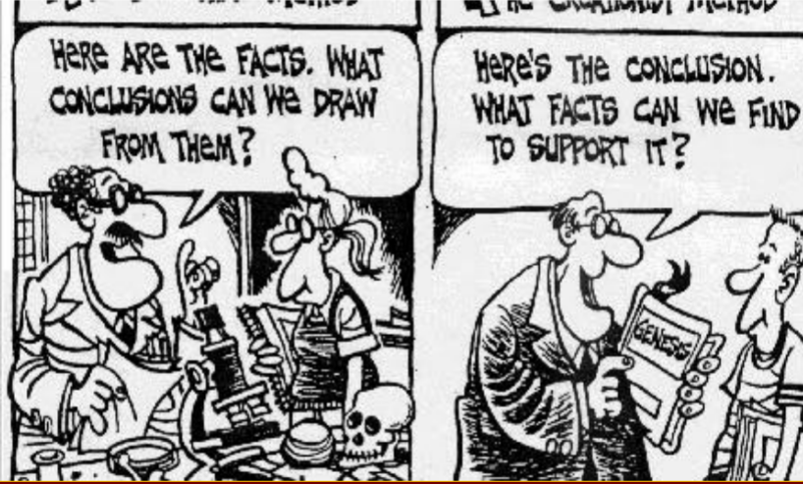
    - Framing Bias
      * Tendency to be influenced by the way a problem is formulated even though it should not affect the solution.
      * How a situation is presented to you affects your decision.
      * Generally, our pain of losing is more powerful than our pleasure of winning, hence we really are at risk of having a strong dislike of or opposition to something.
      * gains and risk seeking to avoid further loss.
    - Hindsight Bias
      * Once we know something, we can’t remember when we did not know
      * This challenges our ability to learn from past failures
    - Overconfidence Bias
      * When we are given factual questions, and asked to judge the probability that our answers are correct, we tend to be far too optimistic.
    - Selective Perception Biases
      * See things from our own personal perspective
      * Organize and interpret events/information based on this perception
      * Influences what we pay attention to and the problems we identify, and the alternatives we develop or consider.
    - Self-Serving Bias
      * Take personal credit for success while blaming outside sources for our failures.
      * Selecting information or making decisions that further our own self-interests instead of the organization or team.
    - Sunk Costs & Constraints
      * Tendency to “honor” already spent resources that are not affected by present or future decisions.
      * Economists would label this behavior "irrational” – it is inefficient because it misallocates resources by depending on information that is irrelevant to the decision being made.
      * Throwing good money after bad.
    - Representation
    - Resource Constraints
    - Immediate Gratification
    - ???WORK IN GROUPS??? (slide 19, but not on this list)
      * ‘08 Fin. Meltdown slide is after Work In Groups
      * Then Reducing Biases Page 22
  + Working in Groups
    - Conformity & Group Think
    - Group Shift
    - Escalation of Commitment
    - Use a clear decision making process like USC-CT to reduce these errors.
  + Session Goals
    - Recognize cognitive biases that influence your thinking and decision making
    - Learn how to overcome these biases in order to make better decisions or complete stronger analysis
    - Understand why it matters
  + Decision Making
    - What do we mean by decision making?
      * When problems or issues arise, we need to make a decision about what to do
      * We engage in a decision-making process to come to the action we want to take
      * During the process, we often use “rules of thumb” or heuristics or shortcuts
      * **We make better decisions using critical thinking**
  + Cognitive Biases
    - **What is a bias?** 
      * We tend to believe or seek out information to preserve our opinions or beliefs
      * This can cause a gap in how we reason and how we should reason
      * This causes us to make bad decisions

* MIND THE GAP